ADS2002

**Forecasting Solar Farm Power Output**



**Project completed by:**

[33051046] Ba Loc Nguyen

[33051038] Ryan Ngo

[31483615] Max Luckie

[33051070] Junwei(Alex) Huang

[33227667] Callum Battilana

[32442289] Youngseo (Kate) Choi

**Executive Summary**

**Brief project outline**

The importance of renewable energy and effective energy management has increased in the race for a sustainable future. The need for creative solutions that harness renewable sources and optimise energy consumption has never been more critical as the world struggles with the challenges of climate change and growing demands for energy. Through a competition that aims to create ideal schedules for both lecture scheduling and battery utilisation, the IEEE-CIS Technical Challenge on Predict+Optimize for Renewable Energy Scheduling offers a unique opportunity to address these issues.

Monash University Clayton is Monash’s largest campus and uses extremely large amounts of power each year. In an effort to reduce electricity costs, Monash has a number of solar panels installed on buildings across campus. These solar panels provide power to the respective buildings they are placed on. Both energy production data (from the solar panels) and energy consumption data (from the buildings) is collected by Monash. Monash also has a weather station that takes readings on a large number of weather-related variables.

**Data sources**

For this project, we have been granted access to the energy production data of six solar panels on Monash, and the energy consumption data of the six buildings they provide energy to. We have also been provided with data from the weather station at Monash Clayton, which contains 8 features, such as temperature, cloud cover and surface solar radiation.

**The Challenge**

The competition focuses on the development of optimal schedules for energy consumption and lecture scheduling. This is achieved by forecasting energy demand and power production for a set of buildings and solar panels. The goal is to find a balance between maximising the utilisation of renewable energy sources, such as solar panels, and minimising energy costs. Participants are required to predict 15-minute energy demand for six buildings and 15-minute power production for six solar panels for the entire month of October 2020 (Phase 1). The evaluation primarily depends on the results for November 2020 (Phase 2).

**Optimization Problem**

The optimization problem that participants are required to solve is at the centre of the challenge. In a situation where renewable energy sources and energy consumption must be balanced, it is not only about predictions but also about making informed decisions to simultaneously maximise efficiency and minimise costs. The competition introduces a comprehensive set of variables, comprising buildings with base loads, solar panels, batteries with specific characteristics, and a range of activities with different energy requirements and constraints. This complexity reflects real-life scenarios where universities or corporations try to optimise their consumption of energy while incorporating renewable energy sources.

**Submission Requirements**

Participants must submit forecasts for energy demand and power production for the specified period. These predictions are critical for developing optimal schedules. Additionally, schedules for the optimization problem must be submitted, considering the energy consumption of buildings, solar panels, and battery usage. These schedules play a pivotal role in achieving the goal of energy efficiency and cost minimization.

**Insightful perception on this competition/project**

The requirement for participants to present an initial overview of their methodology sets this competition apart from others. This synopsis serves as a crucial component for evaluation. It displays the ways of thinking, problem-solving techniques, and innovative strategies participants use to address the challenging obstacles provided by the competition. Additionally, it underlines the rigour and transparency essential for arriving at practical solutions.

The IEEE-CIS Technical Challenge on Predict+Optimize for Renewable Energy Scheduling is not just a competition; it is a platform for creativity and collaboration in the pursuit of sustainable energy management. As the world shifts its focus towards renewable energy sources and responsible consumption, competitions like this play a crucial role in fostering innovation and advancing solutions that can be applied to real-world scenarios.

Eventually, we have explored the significance of the competition in addressing the worldwide challenge of renewable energy optimization and energy scheduling. This challenge transcends the competition itself, as the knowledge and insights gained can be further applied to a variety of sectors, paving the way for a future that is more sustainable and energy-efficient.

# **Introduction**

**The goal of this project** is topredict the energy production of all six solar panels using the weather data. To achieve this, we are provided the energy production data of all 6 solar panels, dating back to late 2019 and a weather dataset, that contains readings taken from a weather station on campus at Monash. The energy production data is 15 minutely and contains data up to and including November 2020, which makes testing final accuracies simple. The weather dataset contains critical features, such as surface solar radiation and temperature, that will be extremely important when predicting the solar power generated by the solar panels. The data from this file is hourly. Being able to efficiently achieve our goal will allow Monash to create an optimal lecture schedule, reducing the overall energy use on campus and reducing energy costs to the University.

This dataset describes the power output of Monash solar power plants every fifteen minutes. It records this data from several different solar panels labelled from 0 to 5. This output data is recorded from 2016 to November 2020. We also have some weather data which describes various features of the weather in the area where Monash is. This includes air temperature, wind speed, dew point temperature, relative humidity, mean sea level pressure (MSLP), and most importantly the solar intensity recorded in the area. This data is recorded in hourly intervals.

What we are trying to achieve is to predict the Monash solar output in November 2020 based on both the power output previously and the weather data. We will do this by using various models to try different strategies of prediction. We will discover which model gives us the best accuracy, and which predictors in our data are the most important in determining power output.

## **Background Research**

## Solar power is generated by the intensity of sunlight hitting the surface of the solar battery (solar intensity). Solar panels generate electricity due to the Photovoltaic Effect. This is when light particles (photons) hit the surface of a solar battery. They absorb into the material of the solar panels. This causes the electrons in that material to be excited and gain energy from the photons. Due to the special chemical structure of the material of solar panels, the added energy causes the electrons to only move in one direction. This causes an electrical current to flow through the material ([Photovoltaic effect - Energy Education](https://energyeducation.ca/encyclopedia/Photovoltaic_effect)) and thus electricity is generated.

***Diagram Describing the Photovoltaic Effect in Solar Panels***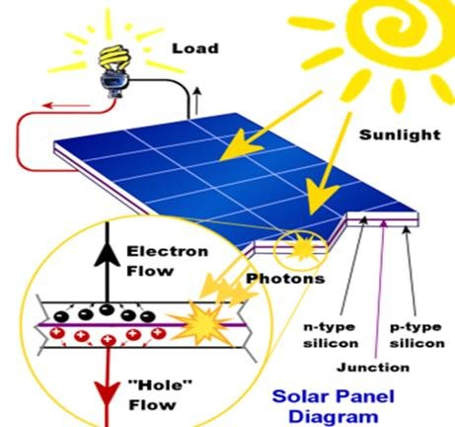

**What Impacts Light Intensity?**

The Intensity on the solar battery is a measure of the number of photons absorbed into the surface of the solar battery divided by the battery’s surface area. We need the beam of sunlight to be perpendicular to the solar battery to get the most intensity with the same amount of light. This of course means that the time of day plays an important role, as the sun is directly overhead on midday, but is tilted slightly at other times. Indeed, we also do not want any cloud cover or any buildings casting a shadow on the panels. This means that cloud cover is an important factor.

We also see that the temperature of the surroundings does play a part in the efficiency of solar panels. Hotter temperatures result in increased resistance in the solar battery. This results in less electricity being produced ([How Does Temperature Affect Solar Panel Energy Production? - Ilum Solar](https://ilumsolar.com/how-does-temperature-affect-solar-panel-energy-production/)).

The humidity in the air also has an impact. The increased water particles in the air reflect light away from the battery, decreasing the amount of photons absorbed into the battery ([What Are the Effects of Temperature on Solar Panel Efficiency? (ecoflow.com)](https://blog.ecoflow.com/us/effects-of-temperature-on-solar-panel-efficiency/)).

## **Data collection**

We were given hourly weather data from Monash University Clayton and 15 minutely solar panel readings from 6 solar panels on Monash University campus.

## **Our approaches**

Some of the modelling approaches we have considered include Linear regression, Multilinear regression, Linear regression with gradient descent, Random Forest and Neural network.

## **Data wrangling**

### Weather dataset

For our weather dataset, we observed that the “model elevation” is constantly 69.6, therefore we dropped the model elevation column. In the dataset, there was a “utc_offset” column, which represents the region of datetime data, therefore we dropped the “utc_offset” column and changed the datetime column into Australian region. In the training and testing dataset, the datetime was given in 15-minute intervals, while in the weather dataset it was given in 1-hour intervals, therefore we interpolated the weather dataset into 15-minute intervals. Our aim is to predict the power generated in November, therefore the training and testing dataset which include the power output are more important, and hence they need to be more precise than weather dataset, so eventually, we decided to interpolate the weather dataset instead of the training and testing datasets. We decided to utilize the observations from the first of October 2019 to the end of November 2020 for training and testing so we dropped the dataset into the same time frame.

### Training and testing dataset

The original training and testing datasets include the power consumed by buildings and power output by solar panel, but our aim was to predict power output by utilising the weather dataset, therefore we removed the power consumption in both datasets. Next, we splitted the datasets into 6 different solar panels, labelled them from solar_0 to solar_5. In terms of training our models, we decided to build models with observations from the first of October 2019 to October 2020 for solar_1 to solar_5 but with all observations in solar_0. This is because there is an apparent gap in the dataset of solar_1 to solar_5 before October 2019 and dropping this gap is a crucial step to ensure we will obtain desirable results within models. On the other hand, solar_0 has a starting timestamp of April 2020 and there is no gap before that date so all observations for solar_0 were utilised in creating predictive models. Considering the testing phase, we used observations from the first of November 2020 to the end of November 2020. For solar_1 to solar_5, since the weather, training and testing datasets have the same time frame, we merged the weather and training datasets together, creating new training dataset which included all the rows and columns from weather and training dataset, and similar process was applied to obtain a merged dataset from individual testing data and weather data. With solar_0, we basically just trimmed the number of observations such that both the starting timestamp of solar_0 and the weather dataset matched before merging. Finally, we dropped all the NaN values in the training and testing datasets, completing the data wrangling process.

# **Data Quality**

### Checking for Outliers

We will check for any suspicious data that is completely different from the rest. To do this, we looked at a pairplot describing each of our variables graphed against each other. We see that there is no data that is significantly distant from the rest of the data. They are all clustered together. This is good news, since there are no obvious outliers and the data is therefore probably all recorded correctly.

*Scatterplot of Each Variable*

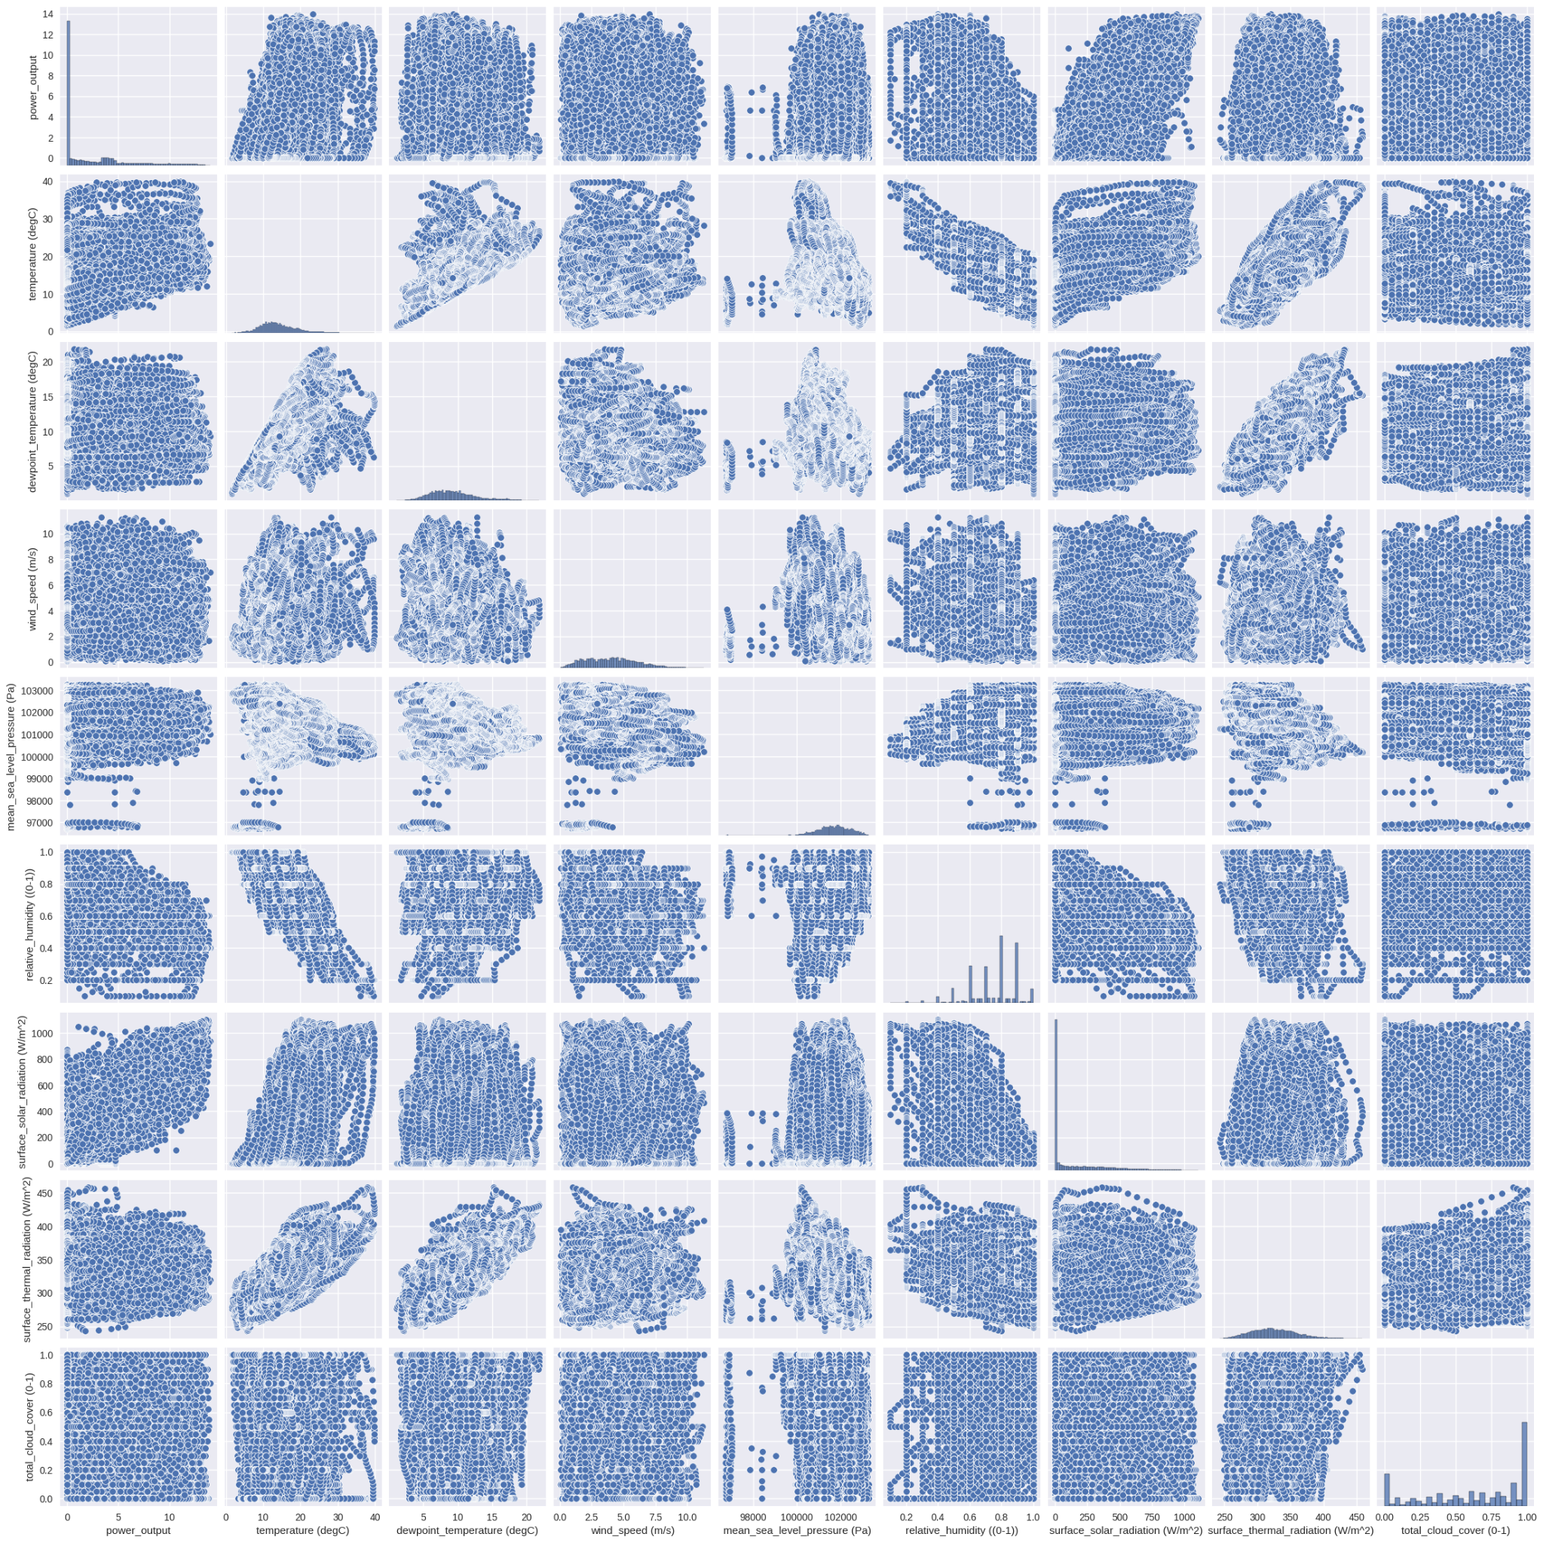

### Interpolation

When we look at the data, we see that there is a gap in the data from April the 16th to May the 20th 2020.

*Interpolated Data (April to May 2020)*

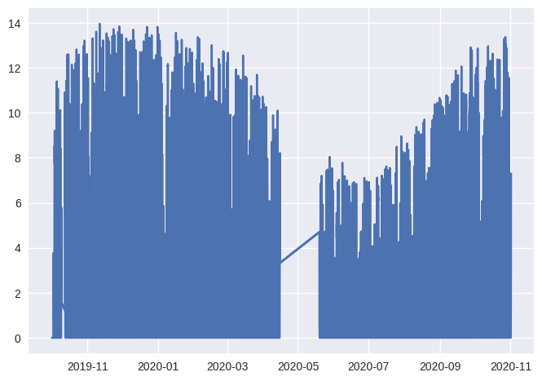

This coincides with the lockdown period, in which it was not possible to gather any data from the solar batteries (Limmer & Einecke, 2022). We recognise that this data was linearly interpolated. In other words, a simple straight line connected the data before the gap to the data afterwards. Clearly this did not match the pattern of the rest of the data, so we performed various different interpolation methods to improve this interpolation.

We tried KNN interpolation. This is where it predicts the interpolated data weighted by the closest previous data points to it. We find that it gave us the exact same interpolation of the exact same straight line. This means that it was simply not able to find any discernible patterns in the data which allow us to predict the data based on the previous other than a straight line. This is despite the fact that we considered one thousand of the closest data points.

We could not really interpolate the data, so we checked the significance of this gap for our future analysis of our models. This was done by comparing the correlation heatmap between each of the variables and power output for when we included the interpolated data and when we did not. We found that there was a minute difference in the correlation between each of the variables. We therefore decided to keep the interpolated data. We admit that it is false data, however removing the data meant that the time series data had NaN values in it, and it created problems for us to model. If it does not affect the data significantly, then we will keep it.

## 

## **Exploratory Data Analysis (EDA)**

### Analysis of Power Output

Firstly, we looked at the average power output over each month.

*Average Power Output over Each Month*

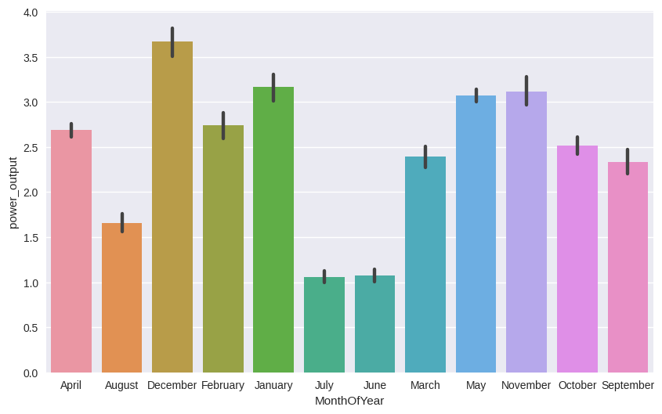

Clearly we see that the month of the year plays a significant role, with summer months (December, January, February) receiving more power output than winter months (June, July, August). This is due to the fact that there is more sunlight on average during the summer months than the winter months (NASA, 2016). We therefore see more power output on average.

Furthermore, we looked at the average power output during the day of each month.

*Average Power Output over Each Day*

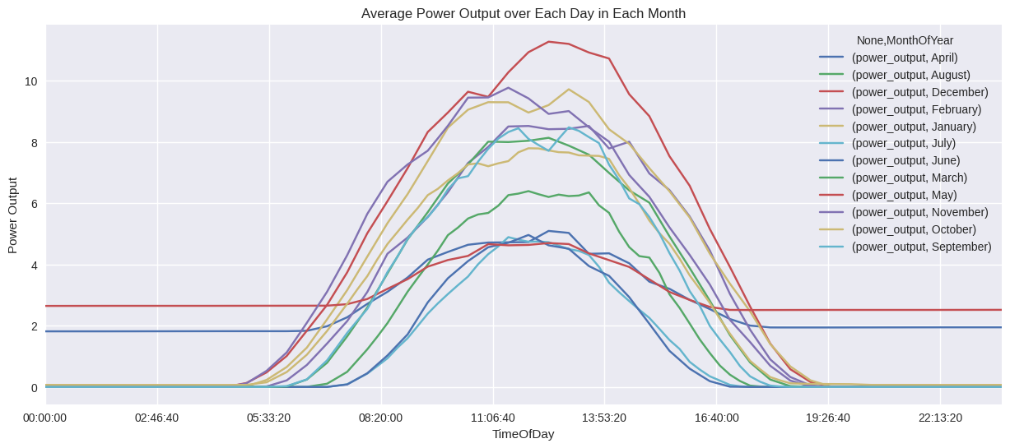

Clearly in most months, we see that the highest power output is at midday. This is related to the fact that the sun is almost perpendicular to the solar batteries during this time (Our Planet Today, 2023). Thus, they receive the highest concentration of solar energy. There are anomalies in April and May. This is just due to the linearly interpolated data. We can therefore discount it as not being representative of the rest of the data.

Finally, we looked at the solar intensity of each month to compare with power output.

*Average Solar Radiation over Each Day*

* 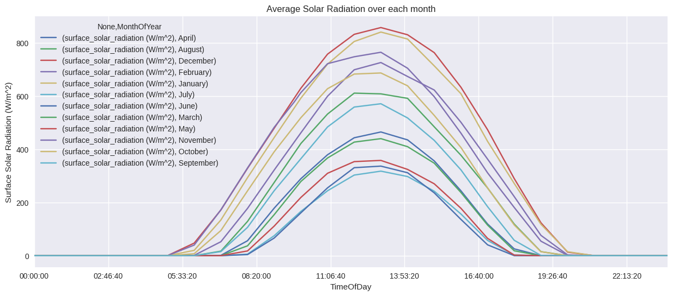

We can see a remarkable similarity between power output and the solar intensity. Both have a sinusoidal pattern in which it is at a maximum during midday. This highlights the very strong relationship between power output and solar intensity.

This data is very useful in looking at the relationship of power output over the time of day and the season. However, we only have a year of data available. If we could model power output over ten years, then we could definitely model the seasonality of this data over each month to predict the power output for November 2020 (using ARIMA models). However, we simply do not have enough data to do this.

### Correlation Between Variables

This is a correlation heatmap, describing how each variable in our dataset is correlated to each other for our solar_2 battery.

*Correlation Heatmap*

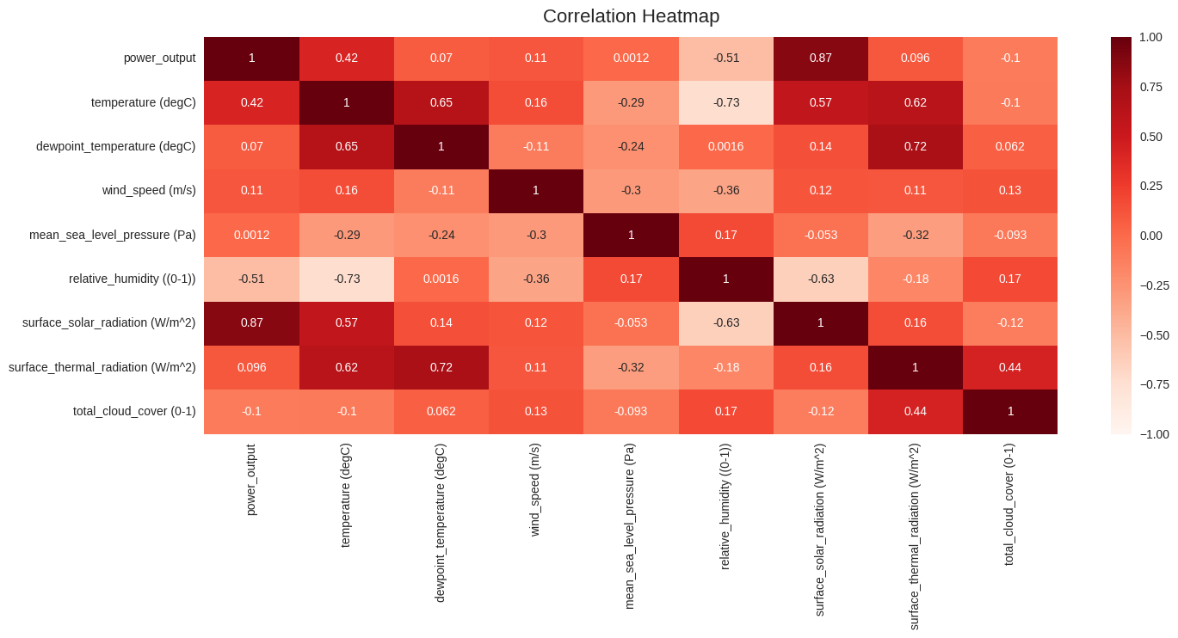

The correlation values range from -1 to 1. If the correlation is close to 1 or -1 it is perfectly correlated. If it is at zero, then it is completely uncorrelated. When the correlation is negative, then when one variable increases, the other decreases. If it is positive, then both increase.

For our target variable (power_output), we can see that surface_solar_radiation (or intensity) is very highly correlated with power output. This was completely expected due to the reliance of solar power on the sun. We can however see that temperature has a moderate positive correlation with power output. This defies our research that this should in fact be negative. In other words, as temperature decreases our efficiency of power output should increase. My hypothesis for this is simply since on average temperature increases during the daytime compared to the night time where there is more power output and more sunlight. We therefore have a classic example of correlation not causation. The sunlight is affecting both power output and temperature, rather than temperature increasing power output. This hypothesis is justified by the fact that temperature has a moderately positive correlation with solar intensity of 0.5. This means that both have a positive relationship with each other.

We see however that humidity has a negative correlation which was predicted. We do not see MSLP (Mean Sea Level Pressure), windspeed, surface thermal radiation, or cloud cover impacting solar intensity. This shows that all these variables are probably not very important factors in determining power output. This will be used to find the simplest model possible with the least features in our **model development** section.

# **Model Development**

## **Linear Regression**

The first option that we used when attempting to model the effect of the power output was a simple linear regression model. Linear regression is a model in which you predict the response variable (power output) based on the independent variables using this equation.

$${response =c_{0}(feature1)+c_{1}(feature2)+....{+c}_{n}(featuren)}_{}$$

Where $c_{0...n}$ describes how much each 0-nth feature or independent variable affects the response variable leaving all the others constant.

Here the independent variables are given within the weather data, and the power output of the solar frame was the response variable. Before analysing the data, we need to split the data into training and testing datasets. After this we can use the linear regression to calculate the R-squared value of the data. And then, from the data that we predict, we find that there exist some negative values on the predicted data. To resolve the issue, we used two methods to avoid this problem. The first method was that we used the logarithm. Before we split the target data, we tried to calculate the log of all of the data, and added a very small value to it to avoid the undefined value of log(0). Subsequently, we splitted the model, and calculated the exponential of the predicted values to re-obtain the original data and calculated the r^2 score. From this method, with the analysis of the r^2 score, we found that it provides some bad r^2 score such as -2000, which does not make sense, so we just decided to remove the logarithm method. The second method that we used to make all the negative values positive is the absolute method. In this case the r^2 score slightly increased. Therefore, we realised that we could use this method, but first, we attempted to normalise the data. After this step we surprisingly could see that the r^2 score was lower after normalizing the data for modelling, which will be explained within the **Results** section.

## **RandomForest**

Given that our dataset has thousands of observations, RandomForest is indeed one of the most useful supervised machine learning algorithms to be utilised in order to obtain decent predictions of power output for each solar panel. Random Forest is an ensemble of decision trees. Each decision tree is used on a random set of data. It sorts whether power output was in a certain range based on a specific criteria of the features. For example, it might say that power output is between 0-5 Watts, since the temperature is less than 10 degrees, and the wind speed is less than 25 km/h. It makes sure to sort the data so that there is the least number of times in which it predicts wrongly in the training set based on the smallest number of branches, or criteria to use.

When it comes to specifying the training dataset, since there are 6 independent solar panels, we attempted to create two efficient functions, in which one of them is to grab the results (R-squared, Mean Squared Error and Root-Mean Squared Error) from our implemented RandomForest model and the other one is to obtain the predictions of the power_output for each of the solar panels in November 2020. After obtaining the predictions, we also made an extra function to plot the predicted power_output against the actual values to observe the goodness of fit of our six RandomForest models.

Furthermore, we also used SelectKbest, one of the feature selection methods to extract the most crucial parameters, and re-train our RandomForest model for each of the solar panel. Subsequently, we attempted to produce a composed plot, which includes the predicted power_output from the original RandomForest model trained from all features, the forecasted power_output from the modified RandomForest trained from the top 3 most important features and the actual values for power_output. This attempt of re-training and selecting top parameters is to compare the performance of the original RandomForest model against the modified RandomForest model and thus draw a pivotal conclusion on the necessity of reducing variables to achieve better predictions.

Since we have assumed, or to be precise, we are previously given the weather dataset for November 2020, we have prior knowledge of the values of the parameters to predict the power_output. This might be one of the limitations since usually, we have to initially predict certain weather parameters, such as surface_solar_radiation, before predicting the power_output for each solar panel.

## **XGBoost**

Another method we have attempted to use was the gradient boosting method using the XGBoost library.

XGBoost is basically a more advanced form of Random Forest, using concepts such as gradient boosting to iterate through the creation of decision trees until it has found one which minimises the Mean Squared Error of the results on the training set.

We have attempted to maximise the accuracy of the predictions of our solar panels’ energy production values through using this library with the variables chosen via feature selection. We have previously identified that the weather features surface thermal radiation, surface solar radiation, mean sea level pressure, dew point temperature and temperature are the features that have the highest impact on the power out values of the solar panels.

Using these features and the XGBoost library, a model was fit to each of our solar arrays in our training data.

## **Neural Networks**

Neural network models are inspired by the structure and function of the human brain. They contain a number of layers, each containing a number of nodes or ‘neurons’ that pass information through the model. The input layer receives raw data, and for this model, the input layer contained 5 neurons, one for each feature used. Then there are a number of hidden layers, with varying numbers of nodes before the output layer, that predicts the solar power generated for the given solar panel.

To determine the 5 features used for the model, recursive feature elimination was used. This starts with all features and then keeps removing the least important until the desired number of features is reached. This left us with surface solar radiation, temperature, total cloud cover, relative humidity, and surface thermal radiation as our features.

After initial training of the model, we noticed that it wasn’t predicting zeros overnight. It was getting very close but predicting slightly positive and negative values constantly. This led to changing the activation function of the output layer to a rectified linear unit function. This was helpful as it maps outputs onto the set of positive real numbers, eliminating negative predictions.

We discovered that increasing the number of neurons in the hidden layers improved predictions around zero but caused overfitting issues. This is typical when increasing the number of neurons in hidden layers. To counteract this, we implemented a regularisation technique to the model. This technique is called dropout. It works by randomly dropping out neurons during training. For our model, we set the dropout rate to 0.2, meaning each neuron has a 20% chance of being eliminated during the training phase. This means that the model cannot become too reliant on certain nodes, reducing the chance of overfitting.

Due to the high number of neurons in each hidden layer, the loss function reduced extremely quickly and not many epochs were required. The final improvement to the model was using the Adaptive Moment Estimation optimizer (ADAM). ADAM adaptively adjusts the learning for each network weight during training. This allows for a dynamic and ideally optimal learning rate to be used for the model, improving results.

This gave us the final model that gave us the results used in this report and the code is available on GitHub.

# **Results**

## **Linear Regression**

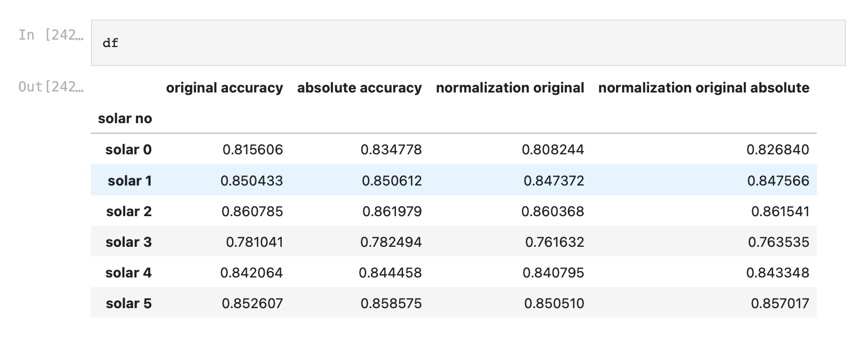

## 

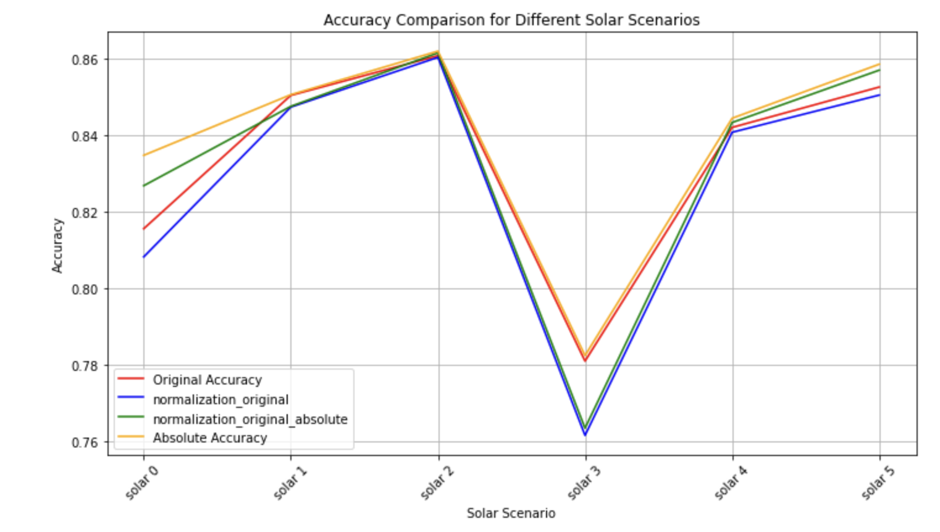

From the graph, we can see that the absolute value has the highest r^2 score. And if we compare the original data with the normalisation data, we can find that original data has higher r^2 score than the normalisation. The reason that might cause this is due to the normalisation, information loss could have occurred. If the normalisation process removes valuable information from the data, the model may not be able to explain the variance in the target variable as effectively as with the original data. The second reason is because of the outlier. Outliers can have a significant impact on the R^2 score. Normalisation can sometimes exaggerate the influence of outliers. If outliers are not handled properly during normalisation, the model's performance may suffer.

## **RandomForest**

Table for models using RandomForest:

|  |  |  |  |
| --- | --- | --- | --- |
| **Solar_no** | **R^2 score** | **RMSE** | **MAE** |
| **Solar_0** | **0.784815** | **7.541011** | **4.408371** |
| **Solar_1** | **0.834788** | **1.735052** | **1.171144** |
| **Solar_2** | **0.859657** | **1.595570** | **0.984584** |
| **Solar_3** | **0.729625** | **1.982997** | **1.282667** |
| **Solar_4** | **0.856935** | **0.955555** | **0.597376** |
| **Solar_5** | **0.855472** | **4.889772** | **2.716174** |

Above is the table of results for RandomForest models utilising all features (except for **power_output, utc_offset_(hrs), model_elevation_(surface))** as discussed in **Model Development** section. Based on the outputs, we could tell that the RandomForest model for solar_2 performs the best in terms of R^2 score. However, even though Solar_4 model’s accuracy is slightly less (around 0.003), its Root-Mean-Squared Error and Mean Absolute Error are both lower than those of Solar_2, which suggests that the model for Solar_4 outperforms the rest, in terms of overall model evaluation. Furthermore, we also managed to generate a plot for each solar panel, which compares the predicted values against the actual values of power_output. Below is the plot for Solar_4:

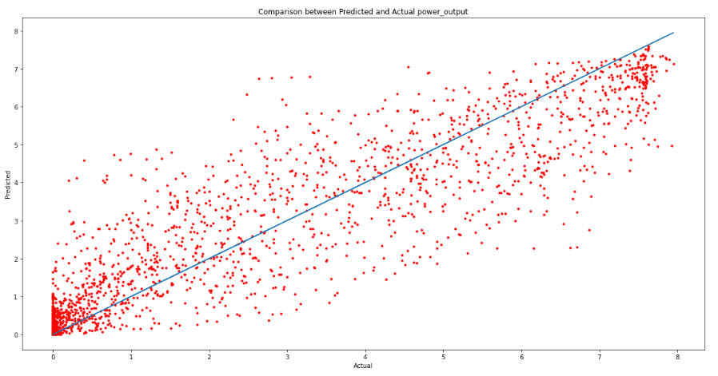

Based on the plot, we can observe the overall trend of the red dots, where they follow the identity line. However, the data points do not entirely gather close to the line, which suggests the discrepancy between the actual and predicted values.

Furthermore, we also wanted to somehow improve the performance of our models, so we tried re-training our RandomForest models with 3 of the most important features. This is when methodologies such as feature selection might come in handy, and indeed, we utilized **SelectKbest** to pull the top 3 most important variables from our dataset, as demonstrated via the barplot below:

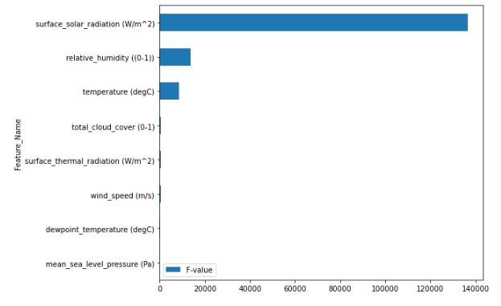

The 3 most crucial parameters are surface_solar_radiation (W/m^2), relative_humidity (0-1) and temperature (degC), which were then used to re-train our RandomForest models. This was to be expected from our prior analysis relating each variable to an impact on power output. Subsequently, after obtaining the new modified models with only significant parameters, we also wanted to compare the predicted power_output of the newer RandomForest models with the power_output of our older RandomForest models, against the actual values.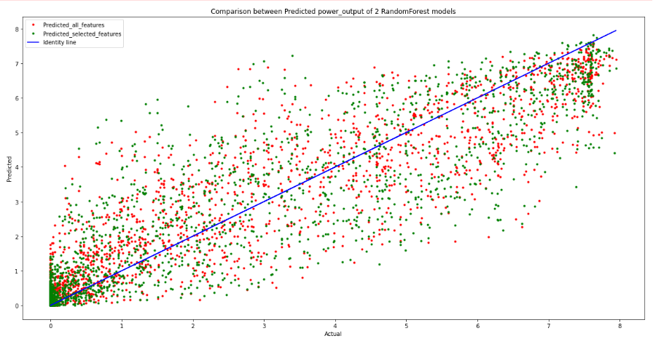

From the comparison plot above, the red dots represent the predicted power_output of the older RandomForest models while the green dots represent the forecasted power_output of the modified RandomForest models, and in this case, we are still considering the two models for Solar_4. As demonstrated, we could also observe that the trend of the green dots is quite similar to the red dots, in which the green data points are scattered around the identity line. However, it is perceptible that the green dots are also not too close to the identity line. This might question the necessity of implementing model with most important variables, given that the gap between predicted and actual values of the newer model is not minimized. Hence, the attempt of feature selection to improve performance of models is not as significant as expected, but ultimately, we managed to make the model less complex, and overfitting was thus reduced.

**XGBoost**

*R2 Score for Each Solar*

|  |  |  |  |  |  |  |  |
| --- | --- | --- | --- | --- | --- | --- | --- |
|  | Solar 0 | Solar 1 | Solar 2 | Solar 3 | Solar 4 | Solar 5 | **Mean** |
| R^2 | 0.40496 | 0.79648 | 0.77582 | 0.67106 | 0.78155 | 0.77087 | **0.70012** |

This is our table of results from XGBoost modelling. While most of the arrays are accurately modelled using this approach with R^2 values of approximately 0.7 and above, the solar 0 array was less successfully modelled. This may be due to the comparative lack of data points recorded at this location.

While these results are promising, other models achieved more successful simulation of the data. For these reasons, other models were selected as our final candidate models to forecast energy production values.

**Neural Networks**

*R2 Score for Each Solar*

|  |  |  |  |  |  |  |  |
| --- | --- | --- | --- | --- | --- | --- | --- |
|  | Solar0 | Solar1 | Solar2 | Solar3 | Solar4 | Solar5 | **Mean** |
| **R^2** | 0.831 | 0.861 | 0.833 | 0.873 | 0.821 | 0.851 | **0.845** |

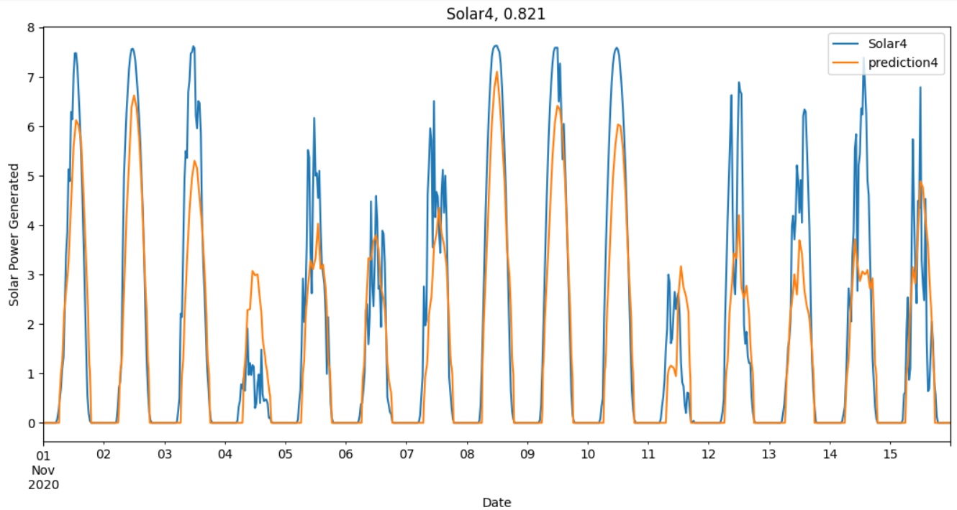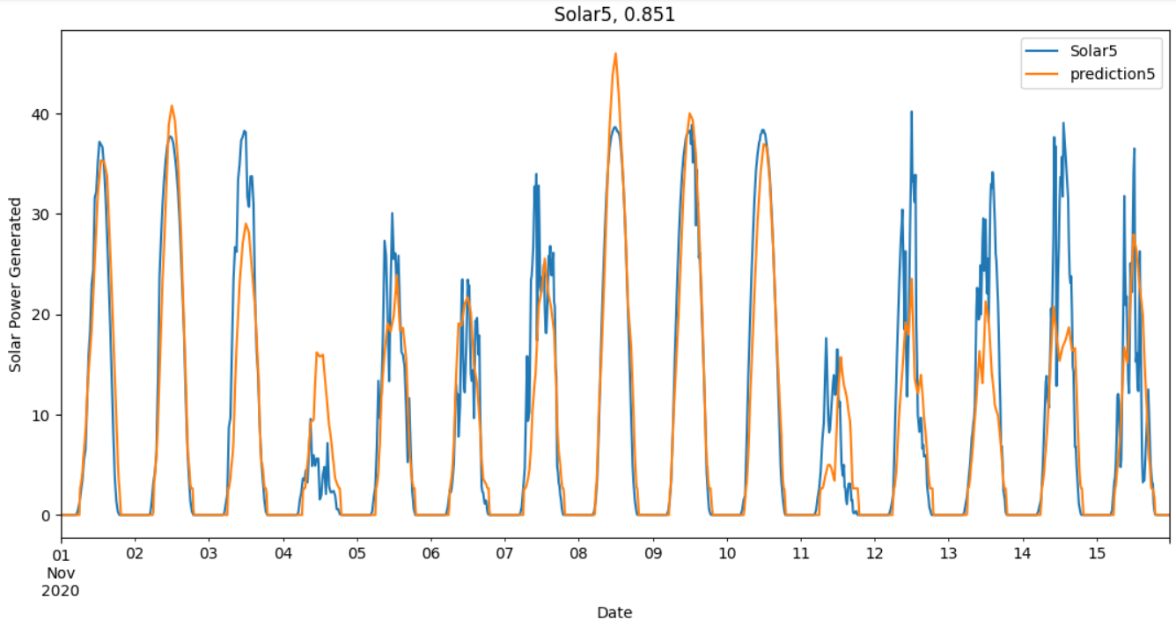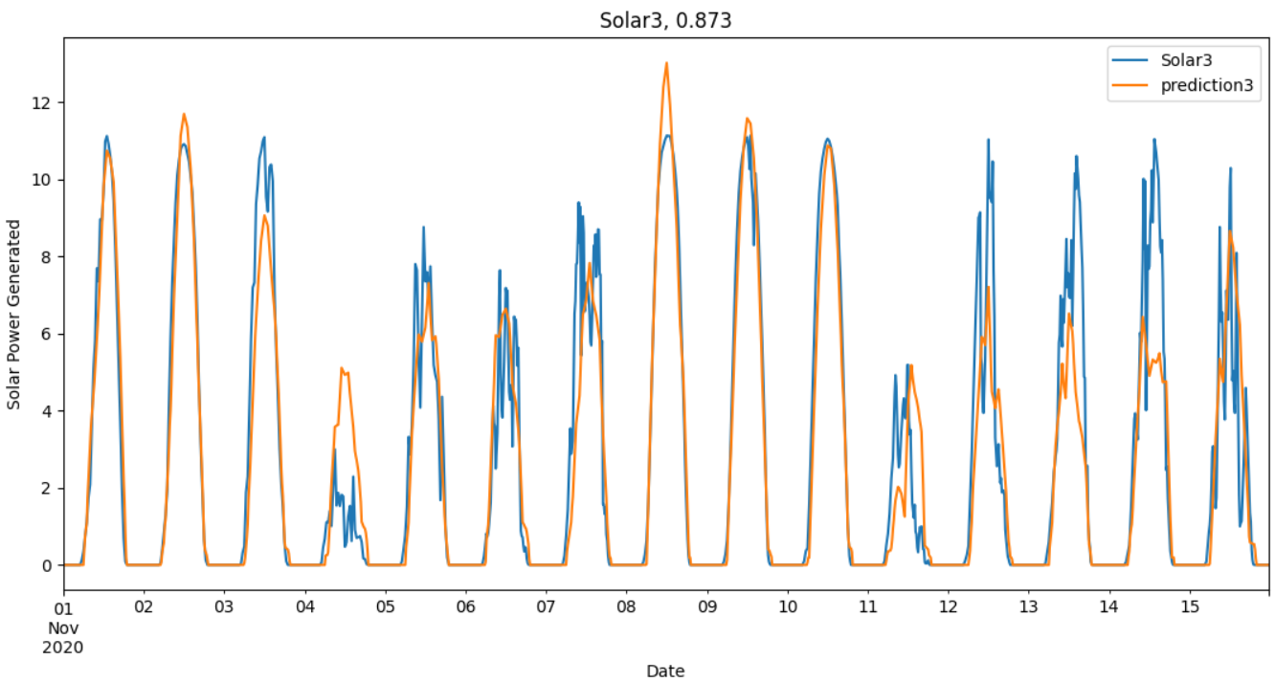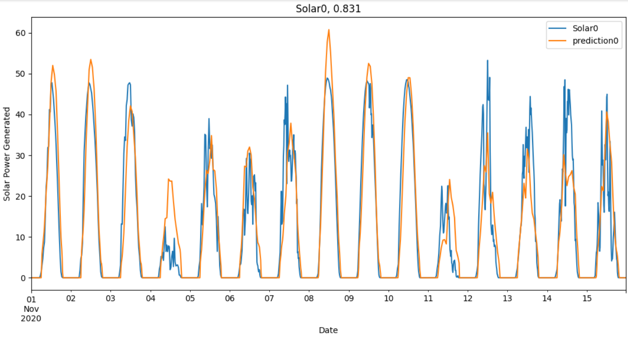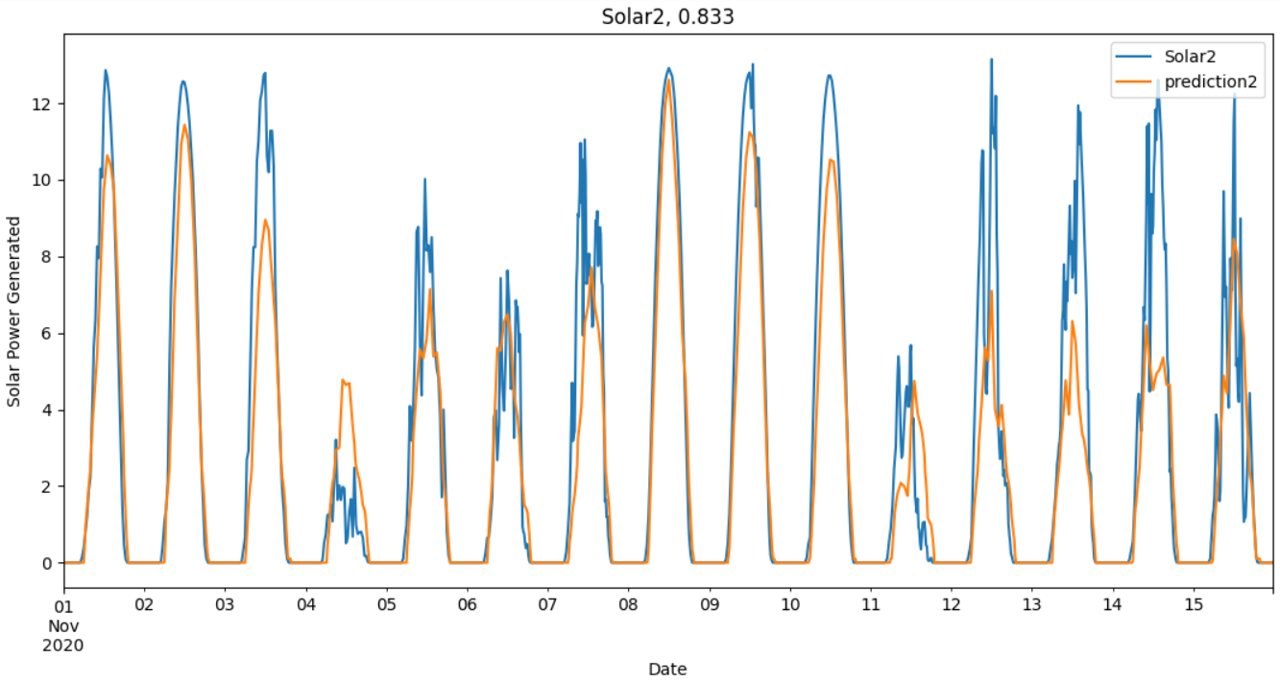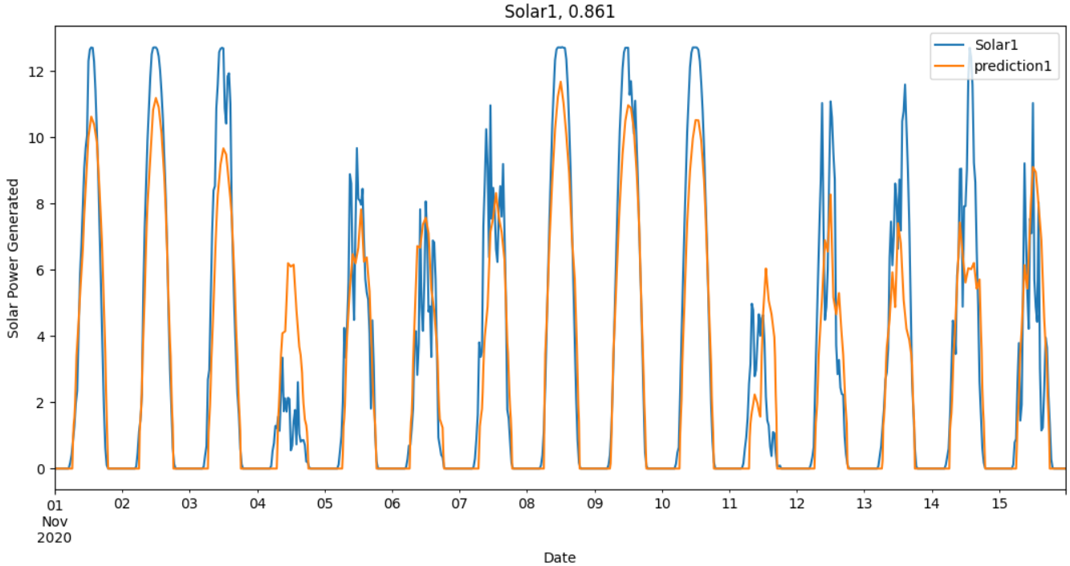This table shows the results of the neural network model when predicting the month of November values for each solar panel. The higher the R^2 value, the less unexplained variability there was in the predictions. The following are graphs for the predictions against the actual values for the first two weeks of November. The titles are the respective solar panel and the associated R^2 score for that solar panel.

All predicted values are shown in orange. The first thing to note in these diagrams is the difference between the best and worst performing predictions. When comparing Solar3 and Solar4, the R^2 value only changes from 0.821 to 0.873. This may sound like a small change but when you look at the predictions, solar3 performs exceptionally for 10 of the 14 days graphed here whereas solar4 underestimates 13 of the 14 days. The reason this resulted in such a small change in the R^2 value is because our model grasped the daily trends of the data exceptionally well and has no unexplained variability overnight due to our accuracy of predictions around 0.

Another thing to note is the general underfitting trend across the predictions. We believe that this could be as a result of a lack of training data and November being the first month of summer, meaning the model wasn’t expecting to have to predict readings this high. For our accuracy in this project, we could have applied a scalar multiple to the predictions to increase our accuracy, however we believe that would only assist us for November and would hurt the model at other times of the year. Therefore, we left the predictions as they are and believe that this would be a great model to use, especially over winter months. With access to more training data, we believe this model would be effective all year round.

# 

# **Conclusion**

The analysis of our model results provides valuable insights into the performance of machine learning models in forecasting solar power output. These findings offer practical implications for comprehending the strengths and limitations of each model and how they can be applied in real-world circumstances.

**Linear Regression:** Our investigation into Linear Regression revealed its ability to perform well, particularly when predicting the absolute value of solar power output. However, the normalization of data led to a slight reduction in the R^2 score, presumably due to information loss. It was also evident that outliers can significantly affect the R^2 score, with normalization potentially exaggerating their influence.

**RandomForest**: The RandomForest models were evaluated for various solar panels, providing us with a detailed assessment of their performance. "Solar_2" emerged as the best-performing model, showcasing a strong predictive capability with a high R^2 score. Notably, model for "Solar_4" exhibited slightly lower R^2 score but outperformed others when considering RMSE and MAE, indicating its superiority considering overall model evaluation. The scatter plots demonstrated a reasonable fit between predicted and actual power outputs, despite slight discrepancies between those values. Our attempt to improve model performance through feature selection yielded mixed results. The effort of modelling based on the three most important variables ("surface_solar_radiation," "relative_humidity," and "temperature") did not significantly reduce the gap between predicted and actual values. However, the models with selected features exhibited reduced complexity and mitigated overfitting issues.

**XGBoost**: XGBoost models provided a reliable means of predicting solar power output for most solar panels, with R^2 scores consistently reaching approximately 0.7 and higher. "Solar_0" was the exception, likely because there are fewer data points compared to others.

**Neural Networks**: Neural Network models demonstrated high R^2 scores across the board, indicating strong predictive performance. The disparity between the best and worst-performing predictions was relatively small, considering the range of R^2 scores. However, a general underfitting trend was observed, potentially resulting from a lack of training data and the unexpected high readings in November.

# Bibliography

Hanania, J., Stenhouse, K., & Donev, J. (2015). *Photovoltaic effect - Energy Education*. Energyeducation.ca. https://energyeducation.ca/encyclopedia/Photovoltaic_effect

pmmilum. (2021, March 5). *How Does Temperature Affect Solar Panel Energy Production?* Ilum Solar. https://ilumsolar.com/how-does-temperature-affect-solar-panel-energy-production/

ECOFLOW. (2023, April 20). *The Impact of Temperature on Solar Panel Efficiency: How Heat Affects Your Solar Energy System*. EcoFlow US Blog. https://blog.ecoflow.com/us/effects-of-temperature-on-solar-panel-efficiency/

Solartech Advisor. (2021, July 18). *How Does Altitude Affect Solar Panels’ Performance? | Solartechadvisor*. Solartechadvisor.com. <https://solartechadvisor.com/altitude-affect-solar-panels/>

Our Planet Today. (2023, June 1). *Why Does the Midday Sun Reach All Longitudes on Earth? - Our Planet Today*. Our Planet Today. https://geoscience.blog/why-does-the-midday-sun-reach-all-longitudes-on-earth/#:~:text=During%20the%20equinoxes%2C%20the%20sun%20is%20directly%20overhead

NASA. (2016). *What causes the seasons? | NASA Space Place – NASA Science for Kids*. Nasa.gov; NASA. <https://spaceplace.nasa.gov/seasons/en/>

Limmer, S., & Einecke, N. (2022). An Efficient Approach for Peak-Load-Aware Scheduling of Energy-Intensive Tasks in the Context of a Public IEEE Challenge. *Energies*, *15*(10), 3718. https://doi.org/10.3390/en15103718

I acknowledge the use of ChatGPT (<https://chat.openai.com/>) to generate materials of background research and make suggestions of accurate parameters of the model xgBoost.. I entered the following prompts on 1 October 2023:

* What are some suggestions of hyperparameters for an XGBoost model used to predict the power output of solar panels using the weather dataset and how could they be used?
* The output from the generative artificial intelligence was adapted and modified for the final code.